**Lab Report 2 - Sensors**

**Nancy Hoang (ndh9tsj) and Nicolas Meneses (nm3bkj)**

**Exercises:**

1. **When we cover the light sensor with our finger it turns off.**
2. **When we point our smartphone flashlight, the light doesn’t appear to change.**
3. **When we change the minValue to 900 and shine the flashlight, the LED light appears to be brighter (unlike exercise 2 where there was no noticeable difference). This happened because we decreased the range of numbers that we are mapping from (before we were mapping from range 800 to 1023 and now from range 900 to 1023) in the map() function. As a result, the same values read from the light sensor would be mapped to lower values in the 0-255 scale (and would be more spread out) when minValue is changed from 800 to 900.**

**For example:**

**Assume the analogRead in the room without flash is equal to 1000.**

**Assume the analogRead in the room with flash is equal to 1020.**

**If minValue is 800 and maxValue is 1023 (223 numbers in scale) then, in the 0-255 (255 numbers) scale, 1000 and 1020 would be mapped to:**

**255/223 = 1.14**

**1000 - 800 = 200**

**200*1.14 = 228 (lightValue with no flashlight)**

**1020 - 800 = 220**

**220*1.14 = 250 (lightValue with flashlight)**

**But, If minValue is 900 and maxValue is 1023 (123 numbers in scale) then, in the 0-255 (255 numbers) scale, 1000 and 1020 would be mapped to:**

**255/123 = 2.07**

**1000 - 900 = 100**

**100*2.07 = 207 (lightValue with no flash)**

**1020 - 900 = 120**

**120*2.07 = 248 (lightValue with flashlight)**

**As expected, the mapping values after setting minValue to 900 are lower and more spread out than before. This is why we can’t detect a brightness difference in exercise 2 after turning on the flashlight, but we can notice it in exercise 3.**

**Assignment:**

**Assignment set-up:**

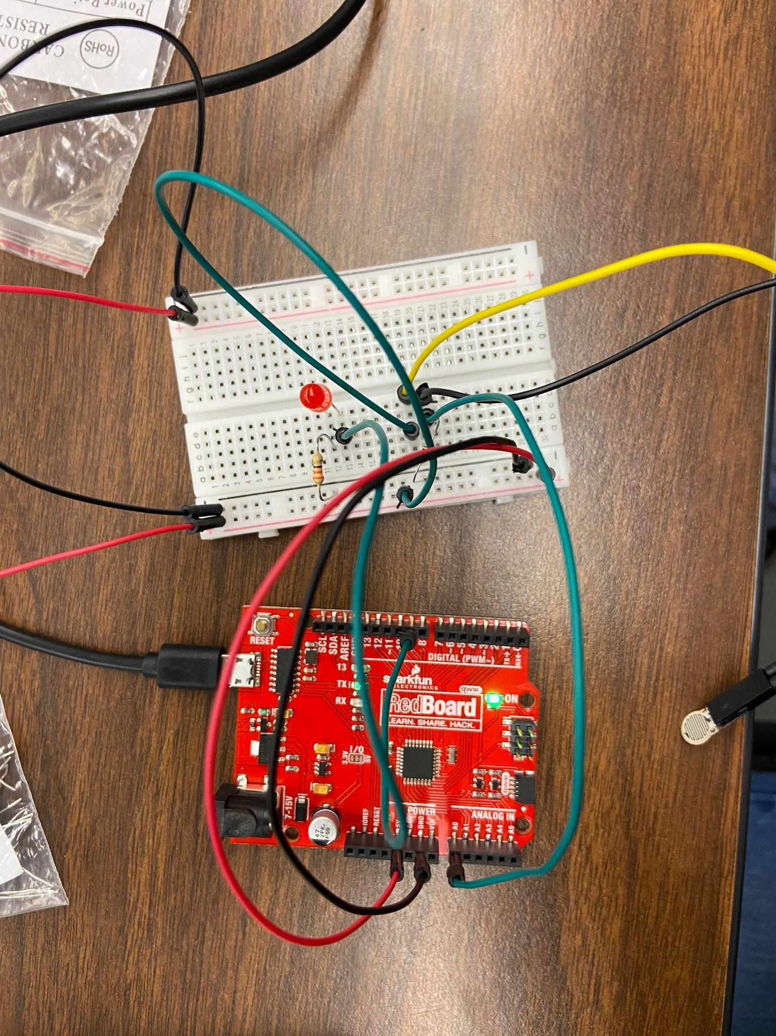

**CODE:**

**int ledPin = 9; // output to LED. Use any PWM-enabled pin (marked ~)**

**int sensorPin = A0; // voltage input. Use any ADC pin (starts with A)**

**int sensorValue = 0; // stores value from ADC**

**int on = 0;**

**void setup()**

**{**

**Serial.begin(115200); // Opens serial port, Baud Rate 115200 bps**

**pinMode(ledPin, OUTPUT);**

**}**

**void loop()**

**{**

**int sensorValue = analogRead (sensorPin); // reads the sensor**

**// returns 0-1023**

**int minValue = 800; // sensor value you consider to be minimum**

**int maxValue = 1023; // sensor value you consider to be maximum**

**int constrainedValue = constrain(sensorValue, minValue, maxValue);**

**// clips values < minValue or > maxvalue**

**int lightValue = map (constrainedValue, minValue, maxValue, 0, 255);**

**// remaps the value to new range (0-255)**

**Serial.println(lightValue); // Prints the value via the serial port**

**if(sensorValue>800)**

**{**

**if(on == 0) {**

**on = 1;**

**digitalWrite(ledPin, HIGH);**

**} else {**

**on = 0;**

**digitalWrite(ledPin, LOW);**

**}**

**}**

**delay(20);**

**}**